**MASTER KEY Worksheet**

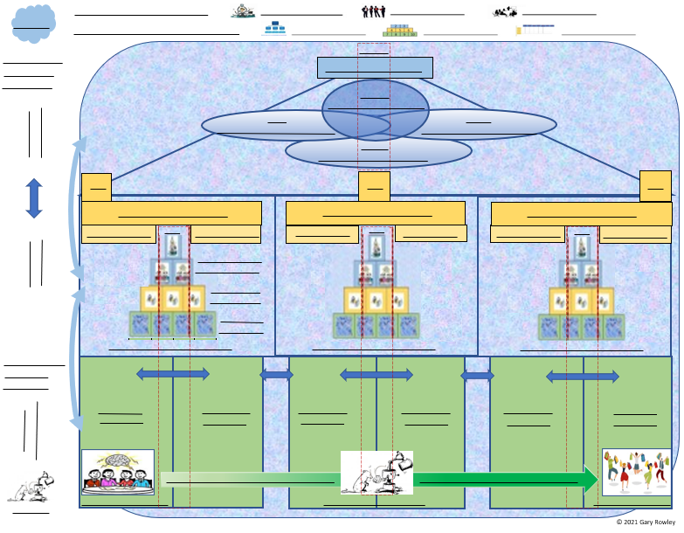

**NUMBERED WORKSHEET ITEMS**

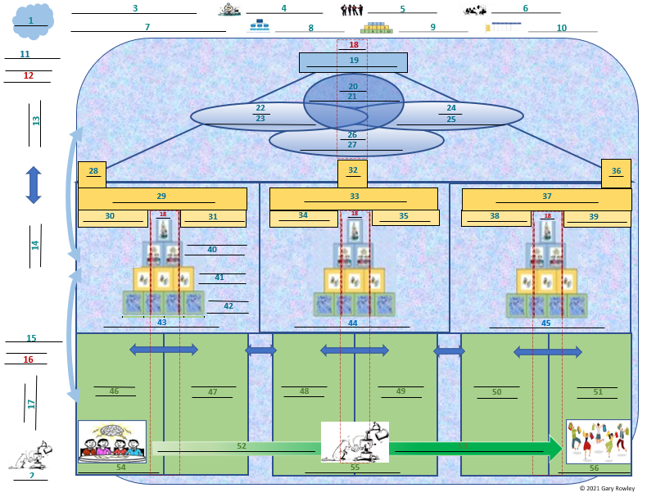

**2**

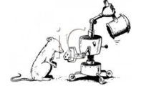

**Master key**

|  |
| --- |
| **LIST THE SEVEN KEY CONCEPTS DISCUSSED IN THE COURSE OVERVIEW**  **a) Create a separate file folder on your computer for each concept.**  **b) Inside each folder create a document named *Folder Index*** |
| **1.** |
| **2.** |
| **3.** |
| **4.** |
| **5.** |
| **6.** |
| **7.** |

|  |
| --- |
| **LIST EACH OF THE 56 WORKSHEET ITEMS BELOW**  **a) Create a separate document named for each of these items and place it in the appropriate Key Concept folder.**  **b) Create a link from each item on this list to its related document which has been placed in the concept folder you designated** |
| **1.** |
| **2.** |
| **3.** |
| **4.** |
| **5.** |
| **6.** |
| **7.** |
| **8.** |
| **9.** |
| **10.** |
| **11.** |
| **12.** |
| **13.** |
| **14.** |
| **15.** |
| **16.** |
| **17.** |
| **18.** |
| **19.** |
| **20.** |
| **21.** |
| **22.** |
| **23.** |
| **24.** |
| **25.** |
| **26.** |
| **27.** |
| **28.** |
| **29.** |
| **30.** |
| **31.** |
| **32.** |
| **33.** |
| **34.** |
| **35.** |
| **36.** |
| **37.** |
| **38.** |
| **39.** |
| **40.** |
| **41.** |
| **42.** |
| **43.** |
| **44.** |
| **45.** |
| **46.** |
| **47.** |
| **48.** |
| **49.** |
| **50.** |
| **51.** |
| **52.** |
| **53.** |
| **54.** |
| **55.** |
| **56.** |

